1. **Calculate the Maximum Switch Current**

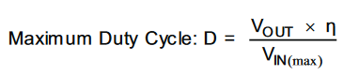

VIN(max) = maximum input voltage = 24V

VOUT = output voltage = 5V

η = efficiency of the converter = 90%

D = 0.208

1. **Inductor Selection**

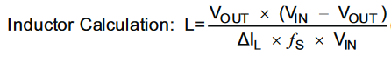

FS = minimum switching frequency of the converter = 47k Hz

ΔIL= estimated inductor ripple current = ΔI =(0.2 to 0.4) x IOUT(max)

ΔIL= 0.2 x 4.8A = 0.96

L = 90uH

1. **Rectifier Diode Selection**

To reduce losses we used Schottkey diodes



IF = average forward current of the rectifier diode = 3.8A

IOUT(max) = maximum output current necessary in the application = 4.8A

1. **Input Capacitor Selection**

This minimum value is necessary to stabilize the input voltage due to the peak current requirement of a switching power supply. The best practice is to use low-equivalent series resistance (ESR) ceramic capacitors. The dielectric material must be X5R or better.

1. **Output Capacitor Selection**



ΔIL = estimated inductor ripple current

COUT(min) = minimum output capacitance = 127uF

**This is the design of the simulated circuit:**

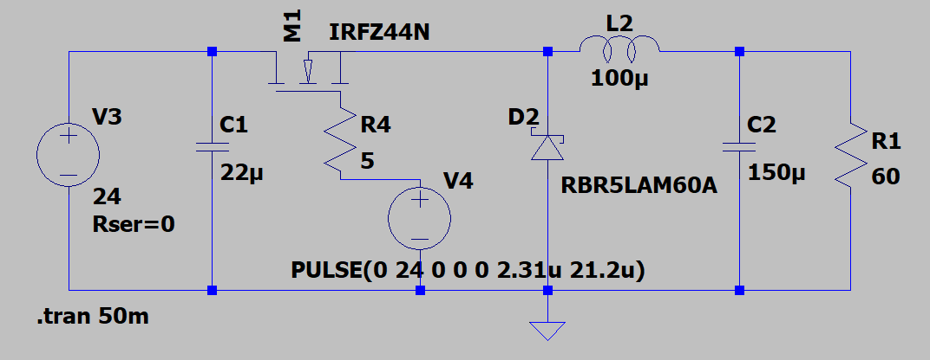

**Output Voltage = 4.90V**

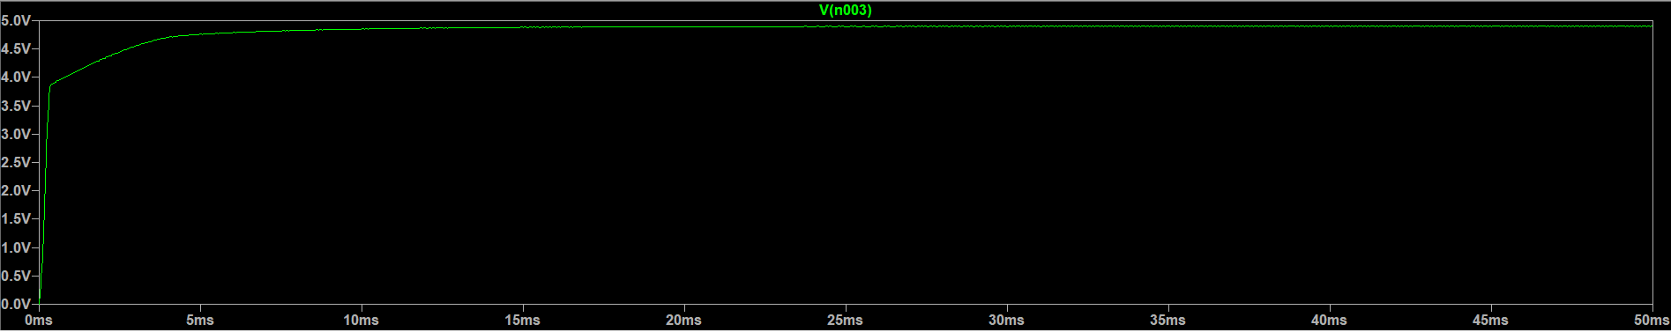

**Output Current = 81mA**

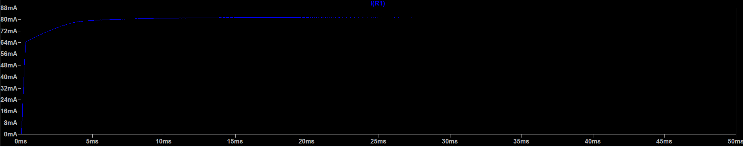

**Output Power = 400mW**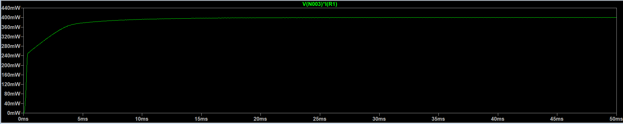

Designed By:

IPD Team No. 80

Suman Swain 60002220213

Yashraj Sangle 60002220261

Stavan Sheth 60002230064

Soumya Gala 60002230067